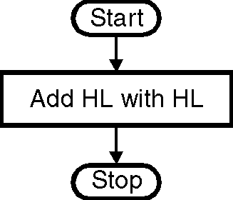
ØØ Explanation :
- Add the number in HL along with itself.
ØØ Flowchart : Refer flowchart 28.
ØØ Program :
Instruction Comment Flowchart 28
DAD H ; HL = HL + HL
HLT ; Terminate program execution

